ICOMES 2024 Travel Grant Application
For the application of the travel grant for ICOMES 2024, the Secretariat kindly requests the applicant's personal information and bank account details. Please carefully review and provide the following information for your application.

1. Application Period: September 8th - September 14th, 2024.
2. Eligibility: ICOMES 2024 abstract acceptance and presenters.
3. Submission: Apply via email to the ICOMES 2024 Secretariat at icomes_abstracts@into-on.com.
4. Selection Notification: Applicants will receive individual notifications via email after the evaluation process.

1. Personal Information

* Name | First | Last
* Country
* Department & Affiliation
* Phone Number
* Address (Zip code)
*E-mail
*Passport No.
2. Bank Information

*Name of Bank
*Bank Account No.
*Branch Name
*Bank Address
*SWIFT CODE
*CHIPS UID
*IBAN Code
*Sort Code
*Routing No.
* Required.
* Fill in the blanks when applicable according to your country.
* Please attach a copy of your passport

Required Supporting Documents
- One (1) completed application form.
- One (1) copy of your passport.
- One (1) copy of your name badge (for on-site attendance verification).
Example of the copy of passport:

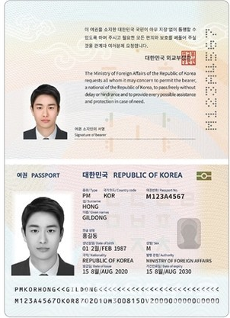

I hereby confirm that the information provided in the submitted application form for the Travel Grants of ICOMES 2024 is true and accurate.
Signature:
Date:

